Experiment worksheet

6.1 The universe was studied by early Australians

Pages 140–141 and 215

Skills lab 6.1: Using a star chart

Planispheres or star charts are very useful maps for locating various stars in the night sky. A sky chart can be easily downloaded each month from www.skymaps.com. A sky chart and calendar are given on page 1, whereas page 2 has various notes and explanations about the objects you can see.

What you need

• A copy of this month’s sky chart (Make sure you click on the Southern Hemisphere option.)

What to do

1 Read the instructions on how to use the sky chart. These are printed around the outside of the circular chart, along with other useful information about the chart.

2 Find the south celestial pole (SCP), which is marked a few centimetres above south on the chart. This is just a place in the sky; there is no star nearby. Over the course of a night, the stars appear to rotate about this point. In the Northern Hemisphere, the North Star is located at the north celestial pole (NCP) and so it is used in navigation to find north.

3 Look at the bottom right-hand corner of the chart, which gives a key to the symbols on the chart. The star magnitudes give the brightness of the stars as viewed from the Earth.

• Can you see that Sirius is the brightest star in the sky?

• Which star is the second brightest?

|  |
| --- |
|  |

• Which is brighter, Alpha or Beta Centauri?

|  |
| --- |
|  |

• Use your star chart to observe the night sky. How many stars and constellations can you identify? Report back to your class.

|  |
| --- |
|  |
|  |
|  |

Experiment worksheet

6.1 The universe was studied by early Australians

Pages 140–141 and 216

Challenge 6.1: Modern-day Australian astronomers

Two prominent astronomers currently practising in Australia are Penny Sackett and Brian Schmidt.

Below are some jumbled facts about these two scientists. Carry out some research to help you match the facts to the correct scientist. Answer any questions below and add any other interesting or up-to-date facts about each person. Find some images to go with your information.

• Conducted major research into extrasolar planets. (What are these?)

• Headed the SkyMapper project. (What is this?)

• Was a member of the High-Z SN search team. (What did this team do?)

• Served on the Board of Directors of the Giant Magellan project. (What is this?)

• Born in 1967 in the USA.

• Has worked as a science reporter for Science News.

• Born in 1956 in the USA.

• Made a major scientific breakthrough in 1998. (What was it?)

• Worked as Director of the ANU Research School of Astronomy and Astrophysics. (When?)

• Worked mainly with exploding stars called supernovas.

• Appointed as the Chief Scientist of Australia. (When?)

• Been jointly awarded the US$1 million Shaw prize for astronomy. (When and why?)

Experiment worksheet

6.2 The Earth is in the Milky Way

Pages 142–143 and 216

Challenge 6.2: Understanding parallax

What you need

• Whiteboard

• Whiteboard marker

What to do

1 Position a student in front of the class and approximately 2–4 metres in front of the whiteboard (if possible).

2 Write a series of numbers across the whiteboard at the same height as the student.

3 Ask each member of the class to decide which number is in line with the student.

• Why do most members of the class see a different alignment of the student and the numbers on the whiteboard?

|  |
| --- |
|  |
|  |

• Relate this activity to the night sky. What do the numbers represent? What does the student represent? What do the members of the class represent?

|  |
| --- |
|  |
|  |

• How would the results of this demonstration be different if the student stood approximately 30 cm in front of the whiteboard?

|  |
| --- |
|  |
|  |

Experiment worksheet

6.2 The Earth is in the Milky Way

Pages 142–143 and 217

Experiment 6.2: Calculating the distance to the Sun

Aim

To determine a value for the distance from the Earth to the Sun using a pinhole screen and compare this with the known value.

Materials

• Metre ruler

• Retort stand (about 76 cm in height)

• Clamp

• Coat hanger

• Sticky tape

• Needle or pin

• 2 × A4 sheets of paper

• Calculator

• Sun visible in the sky

Theory

This experiment uses ratios to determine the distance from the Earth to the Sun. If you know the distance from the pinhole to the image of the Sun, the diameter of the Sun’s image and the diameter of the Sun, you can calculate the unknown – the distance to the Sun.

You will use the following symbols:

• length from pinhole to Sun’s image, Li

• distance to the Sun, LS

• diameter of Sun’s image, di

• diameter of the Sun, dS

You can write an equation using these four quantities. Try writing this equation or ask your teacher for help. It can be written in either fraction or ratio form.

Method

1 Wrap a sheet of A4 paper around the coat hanger and tape securely into place to form a screen.

2 Make a tiny pin hole in the centre of the screen covering the coat hanger.

3 In the centre of the other sheet of paper, draw two lines approximately 7 mm apart and measure the distance as accurately as possible. It doesn’t matter if they are not 7 mm apart, but measure them as carefully as possible and record this value.

4 Tape the A4 paper with the two lines to the top of the base of the retort stand, making sure that the two lines are centred on the base horizontally.

5 Clamp the pinhole screen horizontally so it is facing the screen on the base of the stand and is about 40 cm away from the base.

6 Go outside and point the screen with the pinhole at the Sun. Adjust the position of the pinhole screen along the rod so that the circle of light from the Sun through the pinhole falls exactly between the two lines you drew on the base of the retort stand. The circle of light has to also fill the two lines by just touching both lines.

Results

1 Measure and record the distance between the two lines on the screen. This is di in the equation.

2 Measure and record the distance between the two screens in millimetres. This is Li in the equation.

3 The accepted value of the diameter of the Sun, dS, is 1 392 000 km.

4 Use the equation to perform a calculation based on the measurements to determine a value for LS.

Discussion

1 The correct value for the distance to the Sun is approximately 149 600 000 km. Work out the difference between LS and this value. Call this value the difference.

|  |
| --- |
|  |

2 Divide the difference by the correct value and multiply by 100. This converts it to a percentage and is called the percentage error. Round it off to the nearest whole number.

|  |
| --- |
|  |

3 What factors contributed to this error? (Hint: Which measurements were not exact?)

|  |
| --- |
|  |
|  |
|  |
|  |

Conclusion

Write a conclusion for this experiment that relates the findings to the aim. Mention the size of the percentage error and comment about how the experiment could have been modified to reduce the errors.

|  |
| --- |
|  |
|  |
|  |
|  |
|  |
|  |
|  |
|  |
|  |
|  |

Experiment worksheet

6.4 The galaxies are moving apart

Pages 146–147 and 218

Challenge 6.4: Exploring the Doppler effect

What you need

• Source of sound that can be spun on a rope (known as a Doppler effect apparatus)

What to do

1 Switch on the sound source and spin it around, making sure no one is in its path (see Figure 1).

2 Listen carefully to the pitch of the sound.

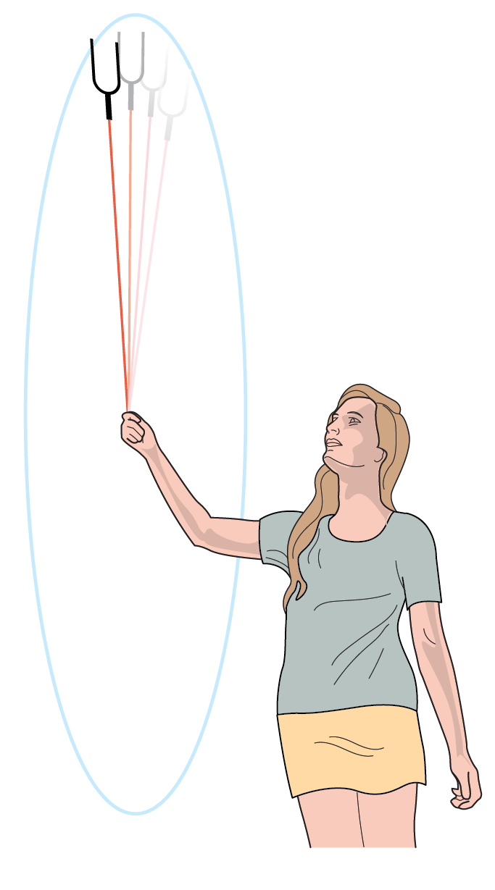 Figure 1 Using the Doppler effect apparatus.

Discussion

1 What happens to the pitch of the sound as the Doppler effect apparatus spins around?

|  |
| --- |
|  |
|  |

2 When is the pitch higher? When is it lower?

|  |
| --- |
|  |
|  |

3 Relate this demonstration to the red shift and blue shift that are seen with starlight.

|  |
| --- |
|  |
|  |

Experiment worksheet

6.4 The galaxies are moving apart

Pages 146–147 and 218

Experiment 6.4: Investigating emission spectra

Aim

To investigate the light emitted by various elements by spectroscopy.

Materials

• Spectroscope

• Discharge tubes for different elements – hydrogen, helium and neon

• Power supply for discharge tubes

Method

1 Connect the equipment and darken the room.

2 Aim the spectroscope at the discharge tube and observe the emission spectrum.

3 Repeat for each tube.

Results

Record the position and colour of the emission lines for each element. Present the results in a table.

|  |
| --- |
|  |

Discussion

1 Each element has a distinct emission spectrum. How is this used to identify the elements present in the universe?

|  |
| --- |
|  |
|  |
|  |

2 If the light from a distant nebula had lines missing from its spectrum, what would that mean?

|  |
| --- |
|  |
|  |
|  |
|  |

Conclusion

How does the light emitted from different elements vary?

|  |
| --- |
|  |
|  |
|  |
|  |

Experiment worksheet

6.5 The Big Bang theory is supported by evidence.

Pages 148–149 and 219

Challenge 6.5: The expanding universe

What you need

• Balloon

• Permanent marker

• Tape measure

What to do

1 Use the ruler to mark three crosses on the side of the balloon 1 cm apart. Mark the centre cross as the origin (O).

2 Inflate the balloon. Measure the distance of each cross from the origin (O).

Discussion

1 How far has each cross moved?

|  |
| --- |
|  |
|  |

2 Predict what would happen to the distance between the crosses if you added more air into the balloon.

|  |
| --- |
|  |
|  |

3 Relate the movement of the crosses to the expansion of the universe.

|  |
| --- |
|  |
|  |
|  |
|  |